 |  | 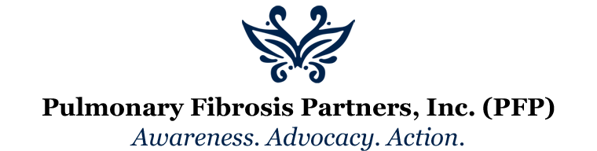
July 1, 2015 | Volume 1, Number 1
Pulmonary Fibrosis Partners, Inc.  P.O. Box 342 Newburgh, IN 47629-0342  info@pulmonaryfibrosispartners.org  We’re on the Web!  www.pulmonaryfibrosispartners.org |  | 2 New Executive Assistants Hired  We are proud to announce that Pulmonary Fibrosis Partners have hired two new Executive Assistants to help propel our success in to the new year.  Sarah Small comes to us from a local law firm and has an extensive background in event planning, structuring mailing and outreach lists, and organization. Sarah will be the backbone of organizing and marketing events for PFP in 2015.  Nicole Taylor comes to us from a legal background as well, and is well-versed in writing and creating social media content. Nicole will be assisting with securing grant funds as well as branding and creating a social media footprint for PFP.  Spot Shoot Coming Up in October!  Stay tuned for details on our upcoming spot shoot in October. We will have prizes, live music, and a great time! Details to follow!  So, what is Pulmonary Fibrosis?  The word "pulmonary" means “lung” and the word "fibrosis" means scar tissue – similar to scars that you may have on your skin from an old injury or surgery. So, in its simplest sense, pulmonary fibrosis (PF) means scarring in the lungs. But, pulmonary fibrosis is more serious than just having a scar in your lung. In PF, the scar tissue builds up in the walls of the air sacs of the lungs, and eventually the scar tissue makes it hard for oxygen to get into your blood. Low oxygen levels (and the stiff scar tissue itself) can cause you to feel short of breath, particularly when walking and exercising. (http://www.pulmonaryfibrosis.org/life-with-pf/about-pf)

